- Usage of e-Leave Module
  - Month View
2.2.1 Introduction
2.2.1.1 Press [Month View]
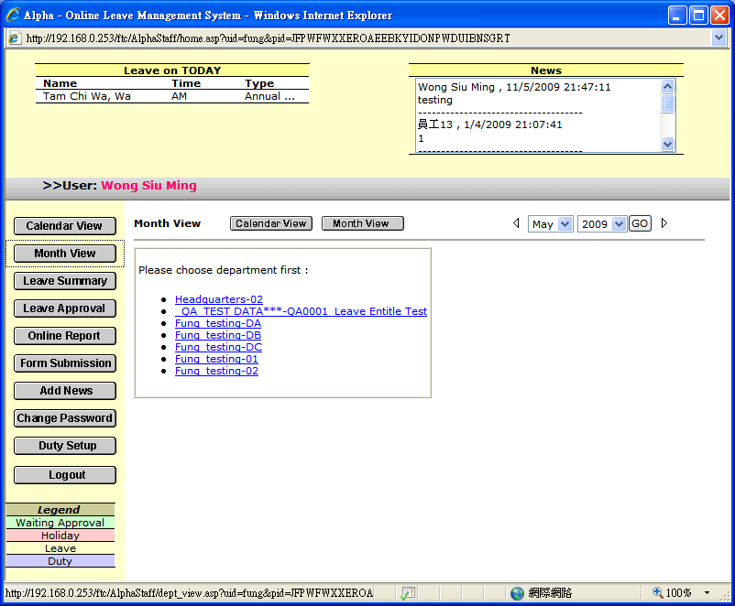

2.2.1.2 Select [Department] to view
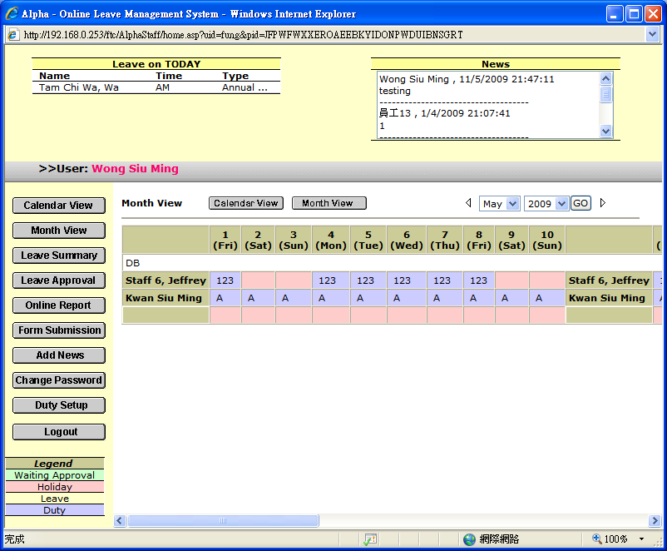

2.2.1.3 Select[Date Range] and press [GO]

or Press『』/ 『』to display previous or next month calendar

Legend
Yellow： Leave Day
Green： Waiting Leave Approval Day
Red： Holiday
Blue： Normal Working Day

